The Glorious Te Deum of Our Lives as Masks of God
An Opening Plenary Keynote Address

Introduction
Arlo & Janis…and Solomon

The Glorious Te Deum of Our Lives as Masks of God: The Song Given
The image of God in its vertical dimension:

The image of God in its horizontal dimension:

What did Luther mean by speaking of us in our callings as God’s masks?

The Glorious Te Deum of Our Lives as Masks of God: The Song Lost
What is the most damnable lie of the devil?

What happens to the song of our lives as fallen human nature “turns in on itself”?
(How is this a loss of both dimensions of the image?)

How does the loss of the glorious Te Deum of living as God’s masks alter our perspective on…
…work?
…marriage and family?
…loving our neighbor beyond our family?

The Glorious Te Deum of Our Lives as Masks of God: The Song Re-Versed
In what way is Jesus the possessor of the image of God in a way far beyond what we could ever be and yet at the same time the bearer of the very same image Adam and Eve once had?
What made it so challenging for Jesus to sing the glorious Te Deum of his life in our place?

How does Jesus completing the perfect Te Deum of his life, death, and resurrection
re-verse our loss of God’s image, both its vertical and horizontal dimensions?

Small Group Discussion Time
Sometimes, when we speak of God’s law demanding perfection, we paint God as a fussy crab who could choose to live with a 94% perfection rate from us if he would just be a bit more reasonable. (“Isn’t an A- good enough for you, God?!?!?!”) How does a holy and
loving God’s creating human beings in his image help us understand why perfection is necessary to live in God’s presence? How does that simultaneously help us understand how hopeless are all fallen human efforts to make God pleased with us by our own efforts?

What most astounds you in regard to the beauty of the Second Adam’s (Christ’s) perfect singing of the Te Deum as a mask of his God and Father?

What “what does this mean” question for what it “sounds” like for us to sing our Te Deum back to God do you hope to hear answered as this presentation moves to its last section?

The Glorious Te Deum of Our Lives as Masks of God: The Song Sung
What is the theme of stanza #1 of our Te Deum?
What is the theme of stanza #2 of our Te Deum?
What is the theme of stanza #3 of our Te Deum?
What is the theme of stanza #4 of our Te Deum?
What is the theme of stanza #5 of our Te Deum?
What is the theme of stanza #6 of our Te Deum?
What is the theme of stanza #7 of our Te Deum?
What is the theme of stanza #8 of our Te Deum?
What is the theme of stanza #9 of our Te Deum?
What is the theme of stanza #10 of our Te Deum?
What is the theme of stanza #11 of our Te Deum?

Small Group Discussion Time
Take a moment quietly to ponder this question before sharing with those around you. Which “stanza” of your Te Deum was most comforting to you? Be prepared to share what led you to choose that stanza.

The presenter, as he puts together his weekly “to do” list, lists his “to do’s” under seventeen different headings (see next page) that represent the various callings God has given him in life. This helps him to see if there are callings in life that are being neglected. In keeping with the emphasis of this conference, those various callings could often be seen as different groups of people God has given him to mentor.

Take five minutes right now to begin creating a list of the various specific callings God has
given you. Obviously there is nothing inspired in the precise way the presenter chooses to list his callings, but the concrete example might prove useful for sparking ideas. Once you’ve made your list, there are some questions for discussion below.

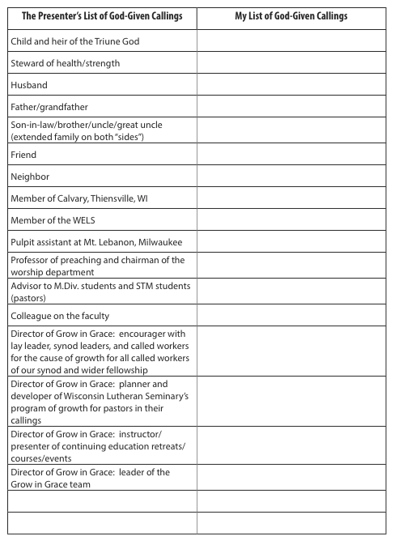
Look at the list of the callings from your life that you have begun to create.
As you are willing, share with your group the one calling in which at the moment it is the hardest for you to find joy as you sing the unique verses of the Te Deum God has given you to sing.

Beyond this discussion: Devote time in prayer while you are at this conference asking God to help you find the joy in that calling even in the midst of the cross! Ask others to pray for you in that as well.

As you are willing, share with your group the one calling in which at the moment is bringing you the greatest joy as you sing the unique verses of the Te Deum God has given you to sing.

Beyond this discussion: Devote time in prayer while you are at this conference to thank God for how he has helped you find joy in that calling. Ask for God’s gift of insight to grasp what you have learned about that calling that provides so much joy. That insight might prove helpful in finding greater joy in many other callings as well.

Closing Thoughts

The angels sang it right!

Verses 1 and 2 will be sung by the soloist. Conference attendees are asked to join in verse 3

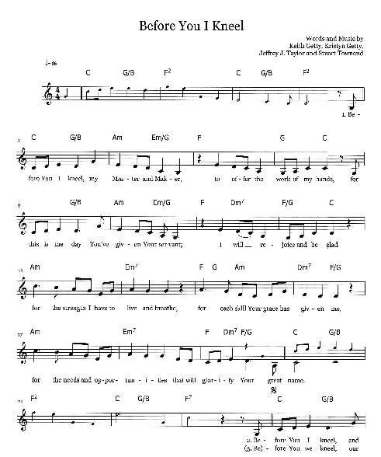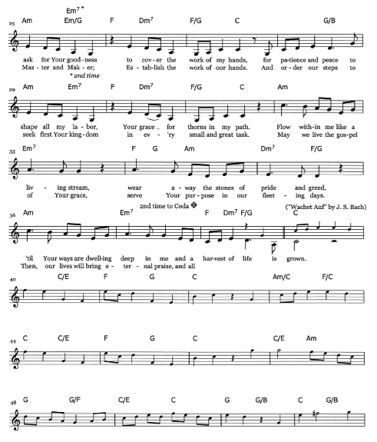
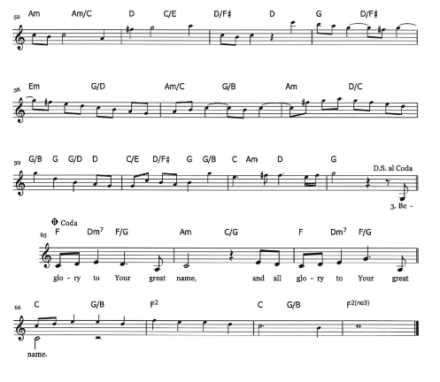
Soloist: Sarah Lambrecht
Pianist: Rachel Fritz
Guitarist: Jill Schultz

