This presentation will dig into the three years of Jesus ministry as found in the Gospels in order to learn what Jesus taught and how he taught it as he traveled with his disciples teaching and preaching throughout Judea and Galilee. By doing so, we can learn important truths and essential principles Jesus used to mentor his disciples. This presentation is not meant to diminish the saving work of Jesus by focusing on his example as a mentor. Nor is it meant to be an exhaustive list of everything one can learn about mentoring from Jesus. Rather, the intention is that the principles discussed will equip the listener to share her faith and life with others as she applies them to her own life and varied situations.

Part 1. Jesus – A mentor for ME
What principles does Jesus live by that teach me how to be a better mentor?

Jesus knew ______________________________________________
Luke 3:21-23 When all the people were being baptized, Jesus was baptized too. And as he was praying, heaven was opened and the Holy Spirit descended on him in bodily form like a dove. And a voice came from heaven: “You are my Son, whom I love; with you I am well pleased.” Now Jesus himself was about thirty years old when he began his ministry.

1. ______________________________________________

2. ______________________________________________

3. ______________________________________________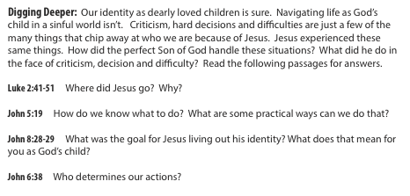

Why does this need to be mentored in our world today?

Jesus knew ______________________________________________
Luke 4:1-2 Jesus, full of the Holy Spirit, left the Jordan and was led by the Spirit into the
wilderness, where for forty days he was tempted by the devil.

1. _________________________ it!

2. _________________________ it!

Jesus knew ______________________________________________
Luke 4:4 Jesus answered, “It is written:

Temptations

1. Take the ___________________________________________________________________

2. I’ll just ____________________________________________________________________

3. __________________________________________________________________________

What can I learn from Jesus about using God’s Word?

1. “It is written”

2. Jesus _____________________________________________________________________

How do we mentor using God’s Word as our words?

1. Answer ___________________________________________________________________

2. Model ____________________________________________________________________

3. Challenge_________________________________________________________________

Jesus knew ______________________________________________
Luke 4:18-19 “The Spirit of the Lord is on me, because he has anointed me to proclaim good news to the poor. He has sent me to proclaim freedom for the prisoners, and recovery of sight for the blind, to set the oppressed free, to proclaim the year of the Lord’s favor.”

Small Group Discussion
Why is it so important for mentors to continually grow in their understanding of an identity based on the saving work of Jesus Christ? (Can you come up with 3-5 reasons?)

I encourage you to “soul search” a little on this question. As a mentor, which of the above principles lived out by Jesus come easily and naturally to you? Which are the more
difficult and cause some struggle? (For example, some find it natural to encourage others with Scripture, but struggle to apply the same good news to their own life. Some are led by the Spirit to serve, but struggle to keep the focus on proclaiming the good news of Jesus instead of solving “problems”).

From your own study of Scripture have you learned principles from the life of Jesus that have equipped you in mentoring situations? What are they?

Describe a mentoring situation in which you applied principles learned from Jesus in
Scripture? What did you learn from that experience?

Part 2. Jesus – A MENTOR for me
What methods and techniques do I observe Jesus using with his disciples that will help me mentor more effectively?

Jesus was ________________________________________________________
Luke 6:40 The student is not above the teacher, but everyone who is fully trained will be like their teacher.
Principles of the Brain and Learning | Making the Case for Best Practices in the Classroom | How did Jesus employ  the Principles of the Brain and Learning? | Referencees
Learning engages the entire  physiology | case for  nutrition,  exercise and  relaxation involved in learning | discussions as they walked along  took the disciples to a quiet place to rest  fed the crowds who had come to see him  fed the disciples after a long night of fishing | Mark 8:27  Luke 24:13-16, 27-28  Mark 6:31  Matthew 15:35-36  John 21:8-10
the search for meaning is innate | case for  activating prior knowledge | told parables  used picture language  asked questions to activate/reveal prior knowledge | Luke 14:15-16  Luke 18:1  John 10:11-14, 8:12, 6:35  John 15:1-5  Luke 13:18  Luke 18:18-23
the search for meaning occurs through patterning | case for themes and threads to create patterns | repeated focus on why the Son of Man came  words and actions line up  Example: words: “Do not worry.”  reminder of actions: “And don’t you remember?”  promise of future action: “it is not you…Holy Spirit.” | Matthew 6:31, 34  Matthew 10:19  Mark 8:17-21  Mark 13:11
learning  always  involves  conscious AND  unconscious processing | case for reflective processing AND time to think things over | “But what about you? Who do you say I am?”  after the apostles returned Jesus took them and  withdrew by themselves  when he heard Lazarus was sick he stayed two more days | Matthew 16:15  Luke 9:10  John 11:1-6
learning is enhanced by challenge and inhibited by threat | case for hi-level, complex  performance | sent the 12 to proclaim the kingdom and heal the sick  “you give them something to eat.” (feeding 5,000)  taught and asked questions in private to give them practice  fear of ghosts and life threatening circumstances | Luke 9:1-6  Luke 9:12-13  Luke 9:18-20  Luke 11:1  Matthew 14:26, 26:56
each brain is unique | case for multiple intelligences approach  visual  kinesthetic  musical  interpersonal  intrapersonal  linguistic  logical-  mathematical | miracles and healings done in the presence of many  Jesus touched people, hands on=“throw your nets”  they sung hymns, reference to psalms  sent the disciples two by two, always among people  “consider the…”, “go and learn what this means”  reading and reference to Scripture, “stringing pearls”  I will ask you a question, you answer me, I tell you | Luke 19:37  Matt 17:7, John 21:6  Matthew 26:30  Mark 6:7  Luke 12:24, Matt 9:13  Luke 4:16-21  Matt 21:24

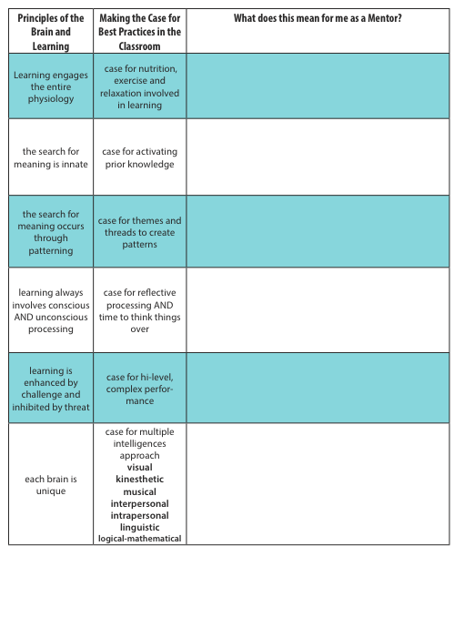
Jesus was ________________________________________________________
John 1:37 When the two disciples heard him say this, they followed Jesus. Turning around, Jesus saw them following and asked, “What do you want?” They said, “Rabbi”, “where are you staying?” “Come,” he replied, “and you will see.”

What was Jewish life like?

What did it mean for Jesus to be a Rabbi?

What are three goals of rabbinical teaching?
1. To give ____________________________________________________________________
2. To shape __________________________________________________________________
3. To prepare _________________________________________________________________

Principles for mentoring we learn from Jesus the Rabbi

1. __________________________________________________________________________
2. __________________________________________________________________________
3. __________________________________________________________________________
4. __________________________________________________________________________

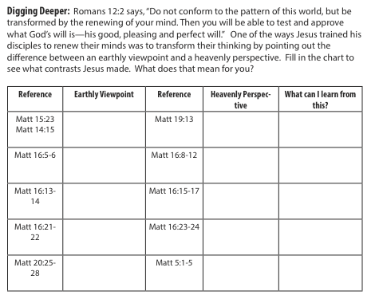

Part 3. Jesus – A mentor FOR me (instead of)
A. Jesus knew _____________________________________________________
John 16:7 But very truly I tell you, it is for your good that I am going away. Unless I go away, the Advocate will not come to you; but if I go, I will send him to you.

1. __________________________________________________________________________

2. __________________________________________________________________________

Sources and Recommended Reads:
Mayhall, Carol. Come Walk with Me. A woman’s personal guide to knowing God and mentoring others.
Kent, Carol. Becoming a Woman of Influence. A bible study designed for women to learn how to become Christ-followers and influencers.
Hunt, Susan. Spiritual Mothering. The Titus 2 model for women mentoring women.
Yancey, Philip. The Jesus I Never Knew. Offers a moving and refreshing perspective on Christ’s life and work.
Chambers, Oswald. Daily Thoughts for Disciples. A serious daily meditation source. Brief thoughts centered on a single Bible verse offer ideas on living a Christian life and answering God’s call to become a disciple.
Thompson, Janet. Woman to Woman Mentoring. A handbook for a structured approach to one on one mentoring between women.
Tverberg, Lois and Spangler, Ann. Sitting at the Feet of Rabbi Jesus. A glimpse into Jewish life at the time of Jesus in order to give context to the life and teaching of our Savior.
Patterson, Donald W. Teaching Like Jesus. A conference paper written to encourage pastors to employ the methods and strategies used by Jesus in his preaching and teaching.
Preach the Word. September –June 2016, Preaching to Millennials. Written by pastors, this series of articles aim to identify “millennial” qualities and how to reach them while maintaining a connection with other generations.
Fogarty, Robin. Brain-Compatible Classrooms. A book that helps educators utilize brain research in their classroom.

Presenter Contact Information:
Dawn Schulz
dawn.schulz@crossoflife.net
647.680.6765

