THE JOURNEY TO BELONG

Tingting Schwartz

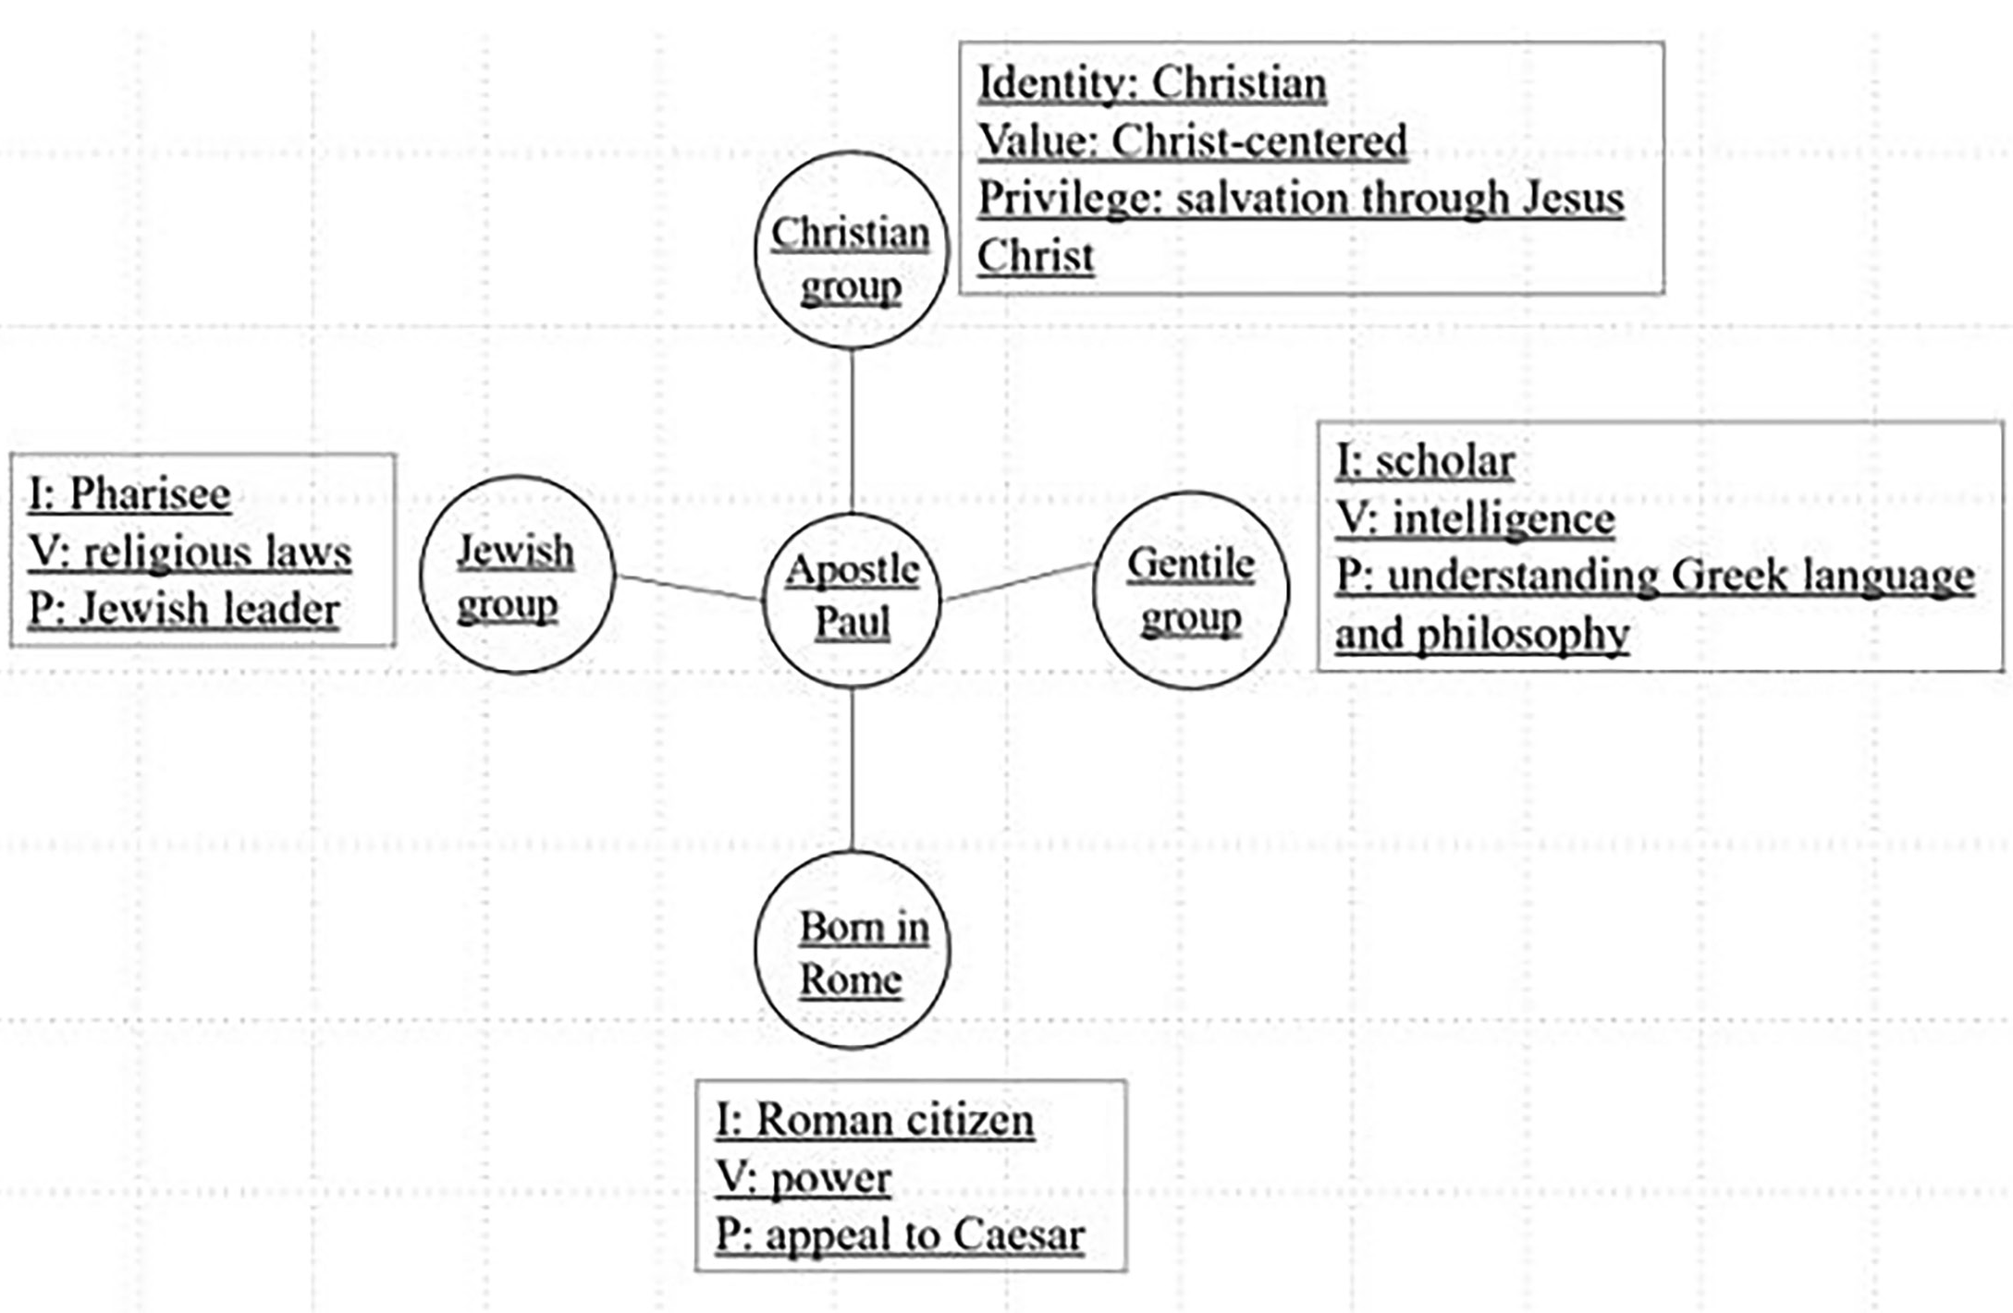
St. Paul’s Multicultural Identity

Biblical references:
- Philippians 3:4–6 & Philippians 3:7-9
- Acts 22:25-29 & Philippians 3:20–21
- Acts 17:22-23 & 1 Corinthians 2:4-7
- 2 Corinthians 4:6
- 1 Corinthians 9:19-23

My Multicultural Identity

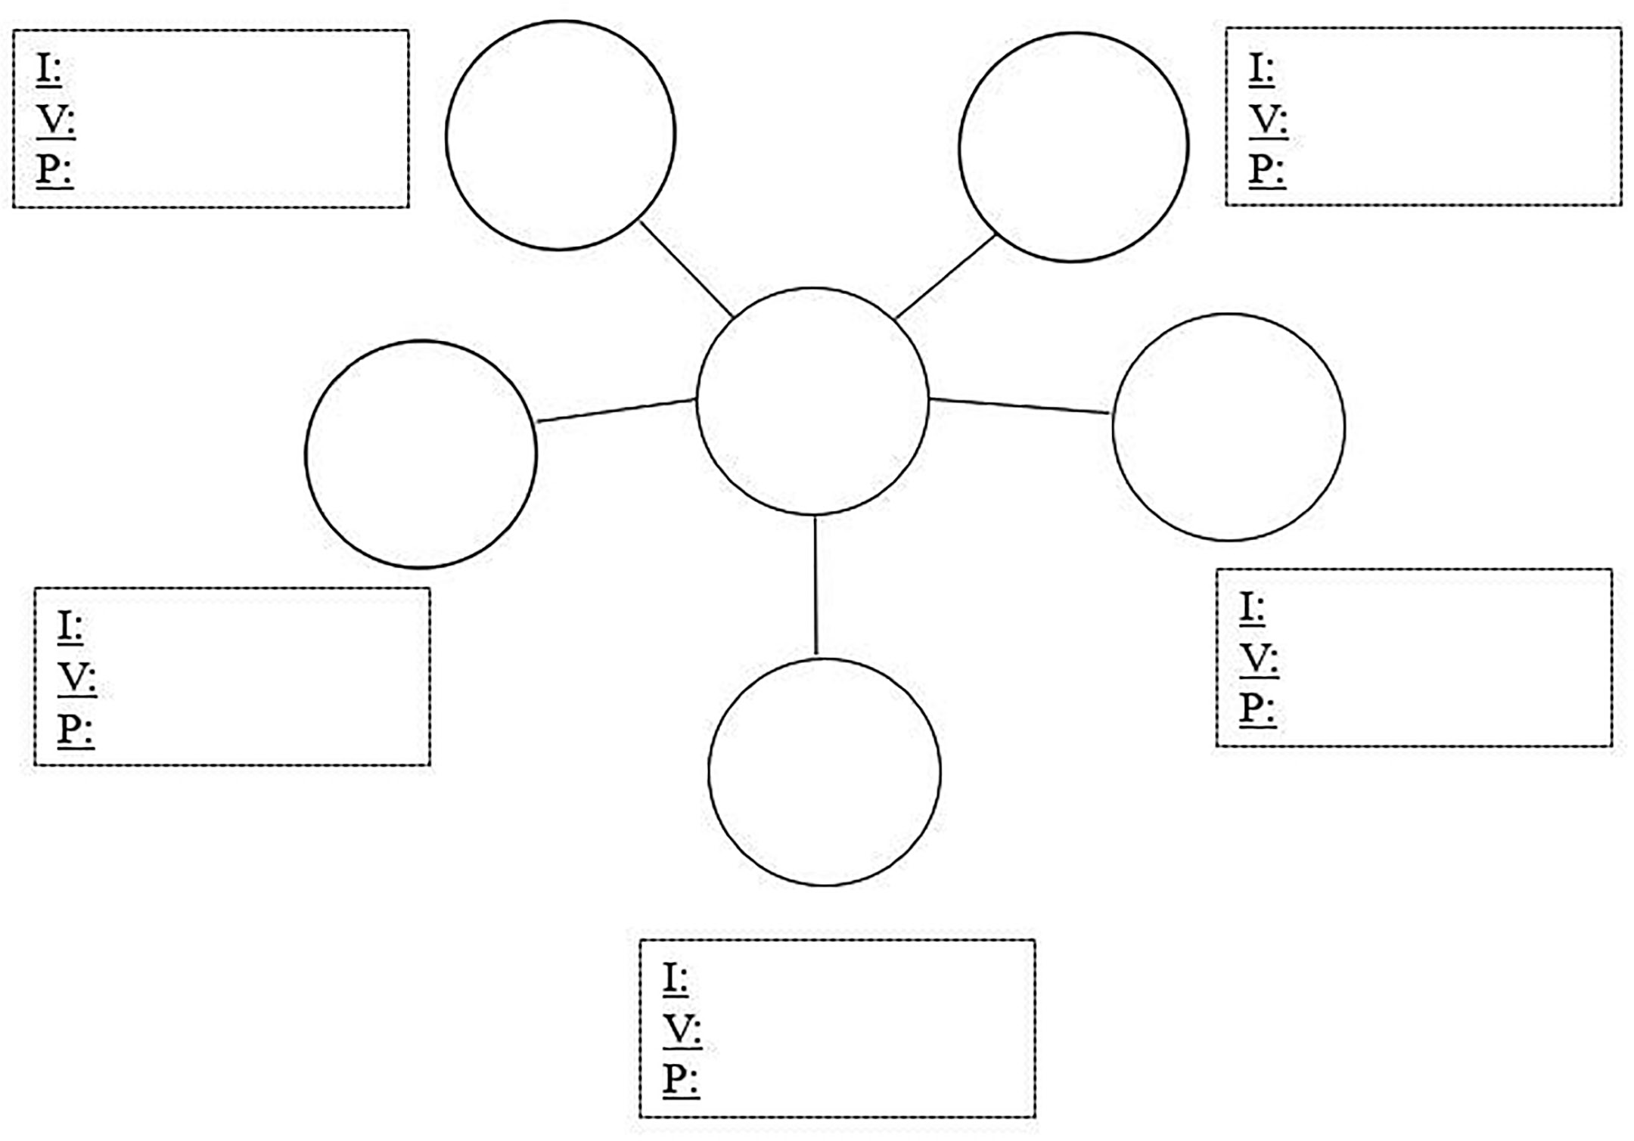

Social groups:
Gender, nationality, ethnicity & race, age, family, disability/ability, religion, education, home/ geographic “roots,” language, socio-economic status, sexual orientation, workplace, hobbies, etc.
Partner with a friend with whom you want to share your faith: what are some differences and commonalities between you and your friend regarding social groups, identities, values/beliefs, and privileges?

My friend’s Multicultural Identity

Our commonalities bring our lives together (possible outreach opportunities):

Your differences are my blessings (asset mindset):

