Know the Love Too Big to Know—Outline

- Introduction: We Lack Perspective
  - The world is too much with us—we lack perspective
  - So we lack perspective—
    - Our God is too small.
    - Our world is too small
    - Our hearts are too small
  - Paul means to give us God’s perspective
- Soar Up into the Heart of God
  - Crucial question: “what” but “how” does God see:
  - Fly high up into the heart of God
Praise be to the God and Father of our Lord Jesus Christ, who has blessed us in the heavenly realms with every spiritual blessing in Christ. (Eph 1:3)
  - “Soaring like falcons above the distress!” (Luther quote)
Note the great art and wisdom of faith….Faith does not despair [even though] God sends trouble… Faith rises above all this and sees God’s fatherly heart behind His unfriendly exterior….
Whoever can learn, let him learn. Let everyone become a falcon and soar above distress. Let everyone know most assuredly and not doubt that God does not send him this distress to destroy him…. He wants to drive him to pray, to fight, to exercise his faith...—
- Unlock the Big Mystery of History—What’s the point?
  - God has made known to us the mystery of his will according to his good pleasure which he purposed in Christ (and that purpose is) to bring all things in the universe together in Christ (Ephesians 1:8-9)
  - Paul is saying: if you want to get the point of it all, to look into the heart of God
    - You don’t have to fly up into the third heaven or plumb the depths of the sea.
    - Look at the Man from Nazareth.
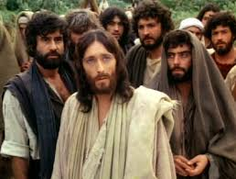
  - That’s not to say we always understand it perfectly.
  - Here the Apostle John gives us perspective: in Revelation he sees:
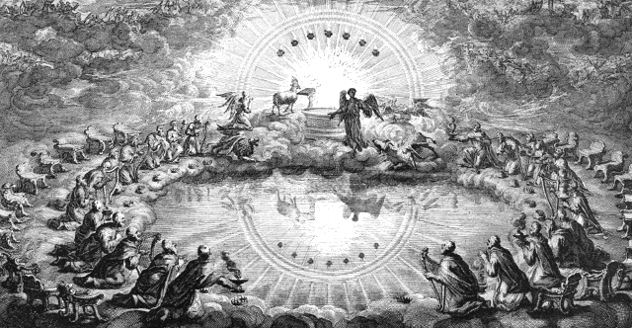
  - In [Jesus] we have redemption through his blood, the forgiveness of sins (Ephesians 1:9)
    - History is written in blood, the blood of the Lamb.
    - He loves us with a woundable love, a love willing to be wounded
    - Willing to bear the name sinner and in place of all sinners to die
    - To give us the full rights as sons and daughters of the king.
  - This was always God’s plan and purpose, not just in general. Paul wants us to take it personally:
God chose us in Christ before the foundation of the world to be holy and blameless in his sight. In love he predestined us for adoption to sonship (Ephesians 1:4-5).
  - This faith lifts us up from our earth-bound perspective to sing:
If God is for us, who can be against us?. No, in all these things we are more than conquerors through him who loved us. (Romans 8:31-37).
- Knowing God’s Big Purpose:
  - People are longing for something more…but
They don’t know who they are or why they’re here

  - Is it any wonder that Paul prays for his Christians
I pray that the eyes of your heart may be enlightened in order that you may know the hope to which he has called you, the riches of his glorious inheritance in his holy people (Ephesians 1:18).
He wants them to know their purpose here—God’s eternal purpose for them:
God’s intent was that now, through the church, the manifold wisdom of God should be made known …according to his eternal purpose that he accomplished in Christ Jesus our Lord (Ephesians 3:10-11).
  - He wants you to know who you are and where you’re going:
    - And God’s purpose is all about the Church.
    - A new people based upon grace, not race; a new creation formed of every tribe, nation, language, and tongue (Ephesians 2:15).
    - Not called to wander in lonely isolation, but to walk in the joyful throng.
    - What does this mean here and now?
      - Show the love of Christ where the love of Christ found you.
      - Love one another—so simple, but so glorious. Love abides.
- Say a big amen
  - It’ all still too much to take in. It’s all still too much to grasp.
  - Now to him who is able to do immeasurably more than all we ask or imagine….to him be glory in the church and in Christ Jesus throughout all generations, for ever and ever! Amen Eph 3:21-22
  - Say a big “AMEN”
Paul O. Wendland
Women’s Ministry Conference
Thursday, July 21st 2022

