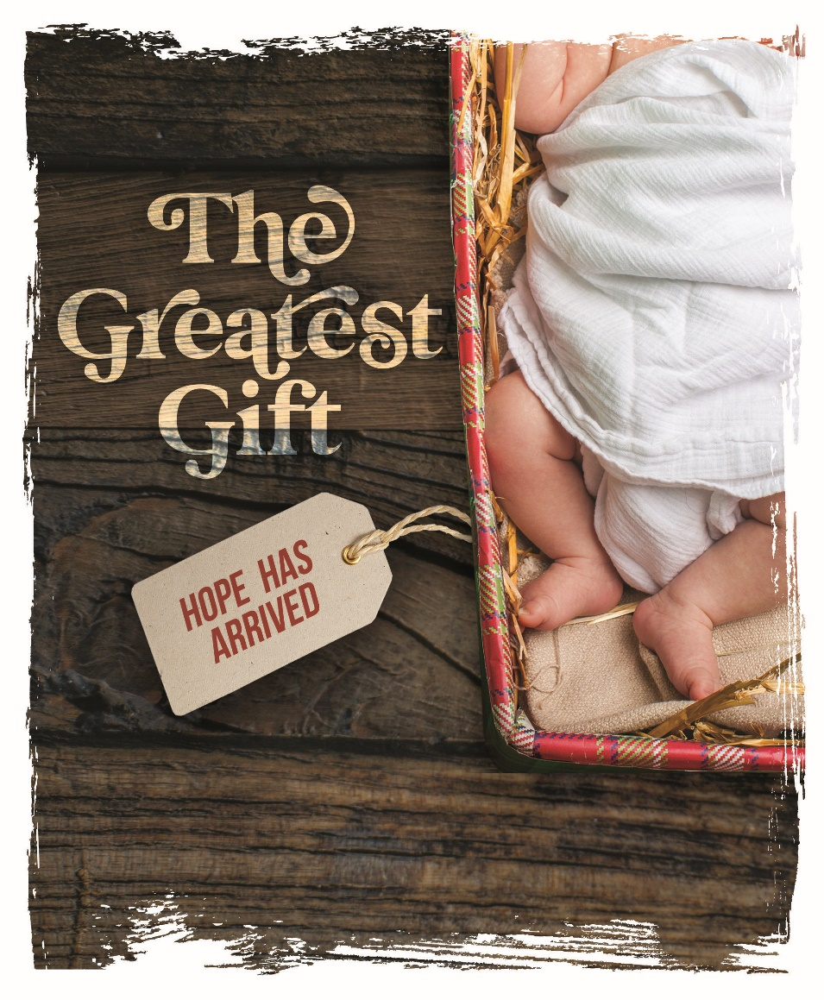

Advent by Candlelight
<insert church name>
<insert city/state>
<insert date>
Welcome, Program Introduction, and Opening Prayer
Narrated by <insert Narrator’s Name>

Opening Hymn – <insert title>
<insert hymn # or composers>
Copyright <insert details>
Used by Permission, <insert copyright license info>

Insert opening hymn lyrics

Scene 1 – Gifts from Mary and Joseph
Narrated by <insert Narrator’s Name>

Musical Selection – <insert title>
<insert hymn # or composers>
Copyright <insert details>
Used by Permission, <insert copyright license info>

Insert musical selection lyrics

Scene 2 – Gifts from the Shepherds
Narrated by <insert Narrator’s Name>

Musical Selection – <insert title>
<insert hymn # or composers>
Copyright <insert details>
Used by Permission, <insert copyright license info>

Insert musical selection lyrics

Scene 3 – Gifts from the Wise Men
Narrated by <insert Narrator’s Name>

Musical Selection – <insert title>
<insert hymn # or composers>
Copyright <insert details>
Used by Permission, <insert copyright license info>

Insert musical selection lyrics

Scene 4 – “Gifts” from the Jewish Leaders
and Roman Soldiers
Narrated by <insert Narrator’s Name>

Musical Selection – <insert title>
<insert hymn # or composers>
Copyright <insert details>
Used by Permission, <insert copyright license info>

Insert musical selection lyrics

Scene 5 – Gifts from the Disciples
Narrated by <insert Narrator’s Name>

Musical Selection – <insert title>
<insert hymn # or composers>
Copyright <insert details>
Used by Permission, <insert copyright license info>

Insert musical selection lyrics

Scene 6 – Gifts from Us
Narrated by <insert Narrator’s Name>

Musical Selection – <insert title>
<insert hymn # or composers>
Copyright <insert details>
Used by Permission, <insert copyright license info>

Insert musical selection lyrics

Conclusion and Closing Prayer
Narrated by <insert Narrator’s Name>

Musical Selection – <insert title>
<insert hymn # or composers>
Copyright <insert details>
Used by Permission, <insert copyright license info>

Insert closing hymn lyrics

Thank You to Our Participants

Narrators | Narrator  Narrator  Narrator | Narrator  Narrator  Narrator
Readers | Reader  Reader | Reader  Reader
Vocalists & Instrumentalists | Vocalist  Vocalist  Vocalist  Vocalist | Instrumentalist  Instrumentalist  Instrumentalist  Instrumentalist
Pre-Event Music | Vocalist  Vocalist  Vocalist  Vocalist | Instrumentalist  Instrumentalist  Instrumentalist  Instrumentalist
Light & Sound | Light | Sound
Planning Committee | Committee Member  Committee Member  Committee Member | Committee Member  Committee Member  Committee Member
“The Greatest Gift” | written by Kristi Meyer

Christmas 2020 Worship Opportunities

Wednesdays, December 2, 9, 16 Midweek Advent Worship
<insert times here>

Thursday, December 24 Children’s Christmas Eve Service
<insert time here>

Thursday, December 24 Christmas Eve Service
<insert time here>

Friday, December 25 Christmas Day Worship
<insert time here>

Thursday, December 31 New Year’s Eve Worship
<insert time here>

Friday, January 1, 2021 New Year’s Day Worship
<insert time here>

