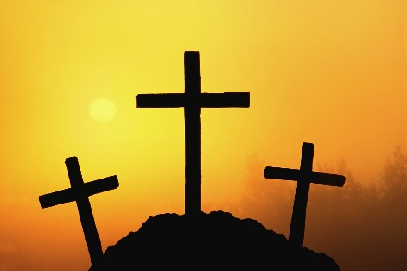

**Lent By Candlelight**

**“Ashes to Stone: Symbols of Lent”**

*We would like to thank all of you for joining us on our Lenten journey. Tonight we will look at the season of Lent and the many symbols connected to it. We will look at the significance of these symbols for the season as well as for our personal journey through life. We pray that through this service you will be edified by the Scripture readings and songs and have a renewed understanding for God’s plan of salvation.*

OPENING PRAYER: (spoken together)

Lord God, you have brought us safely to this hour of evening prayer. We thank you for providing all that we need for body and life. Bless us who have gathered in your name. Forgive our sins. Speak to our hearts. Dispel our sorrows with the comfort of your Word, and receive our hymns of thanks and praise, through Jesus Christ our Lord. Amen.

(Extinguish one candle.)

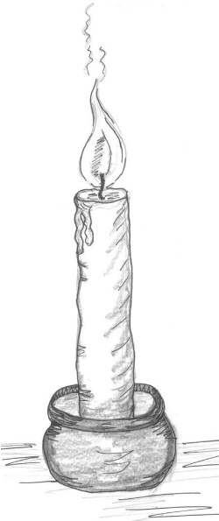**Ashes**

**Job 42: 1, 3, 6**

Then Job replied to the Lord… “Surely I spoke of things I did not understand, things too wonderful for me to know…Therefore I despise myself and repent in dust and ashes.

**Jeremiah 6:26**

O my people, put on sackcloth and roll in ashes; mourn with bitter wailing as for an only son.

(Extinguish the second candle.)

HYMN 268 *Lamb of God, Pure and Holy*

**Palms**

**John 12: 12-19**

The next day the great crowd that had come for the Feast (the Jewish Passover) heard that Jesus was on his

way to Jerusalem. They took palm branches and went out to meet him, shouting, “**Hosanna! Blessed is he who comes in the name of the Lord! Blessed is the King of Israel!”** Jesus found a young donkey and sat upon it, as it is written, “Do not be afraid, O Daughter of Zion; see, your king is coming, seated on a donkey’s colt.” At first his disciples did not understand all this. Only after Jesus was glorified did they realize that these things had been written about him and that they had done these things to him. Now the crowd that was with him when he called Lazarus from the tomb and raised him from the dead continued to spread the word. Many people, because they had heard that he had given this miraculous sign, went out to meet him. So the Pharisees said to one another,” See, this is getting us nowhere. Look how the whole world has gone after him!”

HYMN 131 *All Glory, Laud, and Honor* (vs. 1, 3, 4)

(Extinguish the third candle.)

**Silver Coins**



**Matthew 26: 14-16**

Then one of the Twelve—the one called Judas Iscariot—went to the chief priests and asked, “What are you willing to give me if I hand him over to you?” So they counted out for him thirty silver coins. From then on Judas watched for an opportunity to hand him over.

**Matthew 27: 3-5**

When Judas, who had betrayed him, saw that Jesus was condemned, he was seized with remorse and returned the thirty silver coins to the chief priests and elders. “I have sinned,” he said, “for I have betrayed innocent blood.” “What is that to us?” they replied. “That is your responsibility.” So Judas threw the money into the temple and left.

(Extinguish the fourth candle.)

HYMN 126 *Lord Jesus, You Are Going Forth*

vs. 3 – Congregation

vs. 4 – Soloist

vs. 5 – Congregation

**Crown of Thorns**



**Mark 15: 16-20**

The soldiers led Jesus away into the palace (that is, the Praetorium) and called together the whole company of soldiers. They put a purple robe on him, then twisted together a crown of thorns and set it on him. And they began to call out to him, “Hail, king of the Jews!” Again and again they struck him on the head with a staff and spit on him. Falling on their knees, they paid homage to him. And when they had mocked him, they took off

the purple robe and put his own clothes on him. Then they led him out to crucify him.

(Extinguish the fifth candle.)

HYMN 127 *Stricken, Smitten, and Afflicted*

**Nails & Cross**



**Luke 18: 31-34**

Jesus took the Twelve aside and told them, “We are going up to Jerusalem, and everything that is written by the prophets about the Son of Man will be fulfilled. He will be handed over to the Gentiles. They will mock him, insult him, spit on him, flog him, and kill him. On the third day he will rise again.” The disciples did not understand any of this. Its meaning was hidden from them, and they did not know what he was talking about.

**Mark 15:22-32**

They brought Jesus to the place called Golgatha (which means The Place of the Skull). Then they offered him wine mixed with myrrh, but he did not take it. And they crucified him. Dividing up his clothes, they cast lots to see what each would get. It was the third hour when they crucified him. The written notice of the charge against him read: THE KING OF THE JEWS. They crucified two robbers with him, one on his right and one on his left. Those who passed by hurled insults at him, shaking their heads and saying, “So! You who are going to destroy the temple and build it in three days, come down from the cross and save yourself!” In the same way the chief priests and the teachers of the law mocked him among themselves. “He saved others,” they said, “but he can’t save himself! Let this Christ, this King of Israel, come down now from the cross, that we may see and believe.” Those crucified with him also heaped insults on him.

(Extinguish the sixth candle.)

Hymn 119 *Were You There*

**Colossians 2:13-14**

When you were dead in your sins and in the uncircumcision of your sinful nature, God made you alive with Christ. He forgave us all our sins, having canceled the written code, with its regulations, that was against us and that stood opposed to us; he took it away, nailing it to the cross.

**John 3:16**

**For God so loved the world that he gave his one and only Son, that whoever believes in him shall not perish but have eternal life.**

**Stone**

**Mark 15: 42-47**

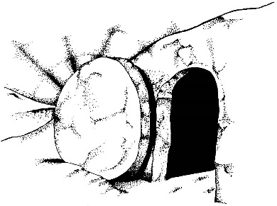It was Preparation Day (that is, the day before the Sabbath). So as evening approached, Joseph of Arimathea, a prominent member of the Council, who was himself waiting for the kingdom of God, went boldly to Pilate and asked for Jesus’ body. Pilate was surprised to hear that he was already dead. Summoning the centurion, he asked him if Jesus had already died. When he learned from the centurion that it was so, he gave the body to Joseph. So Joseph bought some linen cloth, took down the body, wrapped it in the linen, and placed it in a tomb cut out of rock. Then he rolled a stone against the entrance of the tomb. Mary Magdalene and Mary the mother of Joses saw where he was laid.

(Extinguish the seventh candle.)

HYMN 110 *My Song Is Love Unknown, vs. 1, 6*

**I Peter 2:6**

For in Scripture it says: “See, I lay a stone in Zion, a chosen and precious cornerstone, and the one who trusts in him will never be put to shame.”

(Relight the center candle.)

HYMN 110 *My Song Is Love Unknown, vs. 7*

*Silent Prayer*